iPads in Elementary Education
Instructional System Design
Developed by: Matthew Tombs, Dawn Danuser, Serena Allen, Kendra McCormick
Name | Role | Contributions
Matthew Tombs |  | Leader for: Needs Assessment, Formative Evaluation, Contextual Analysis
Dawn Danuser | Project Manager | Leader for: Learning Objectives, Materials for Training Program or Learning System, Implementation Plan for Your Product
Serena Allen |  | Leader for: Broad Goals and Big Ideas, Formative and Summative Evaluations, Learner Analysis
Kendra McCormick | SME | Leader for: Task Analysis
All Group Members |  | Worked together to coordinate all pieces of the project, including the editing for the final paper.
Focus: Demonstrating to teachers how to utilize the iPad device for instructional purposes in their classrooms. Using their iPads, teachers will learn the basic steps involved in setting up and becoming familiar with their iPads. Furthermore, teachers will learn about iMovie and various free educational apps that can be implemented into their curriculum to be used with their students.
Approach: Small group (10-20 teachers)
Audience: Elementary (K-6) school teachers
Session 1: iPad basics, photos, camera, video, screenshot
Session 2: Apps: Puppetpals
Session 3: iMovie for iPad
Session 4: Creating iMovie by integrating apps
Session 5: Apple TV and presentation of iMovie

Table of Contents
Section 1: Desired Results
A. Broad Goals and Big Ideas ….................................................................................3
B. Learning Objectives …............................................................................................3
C. Needs Assessment …...............................................................................................5
D. Task Analysis …......................................................................................................6
Section 2: Evidence of Acceptable Results
A. Formative Evaluation …..........................................................................................6
B. Summative Evaluation (including Assessment of Learning) …..............................7
Section 3: Learning Experiences and/or Instruction
A. Learner Analysis ….................................................................................................9
B. Contextual Analysis …..........................................................................................10
C. Types of Learning Experiences and/or Instruction................................................12
D. Materials for Training Program or Learning System.............................................17
E. Implementation Plan for Your Product, including Schedule and Logistics...…17
Appendices
Appendix A: Needs Assessment Instruments and Evaluation Materials
Needs Assessment Instruments ….....................................................................................18
Task Analysis for Puppetpals …........................................................................................23
Task Analysis for iMovie …..............................................................................................26
Formative Evaluation Instruments …................................................................................32
Summative Evaluation Instruments...................................................................................33
Appendix B. Materials, Schedules, Outlines, etc.
Informational iPad Wiki....................................................................................................35

Desired Results
Broad Goals and Big Ideas:
The face to face small group instruction described in this document is designed to deliver instruction to K-6 teachers that desire to use the iPad device for instructional purposes in their classrooms. iPads are emerging technologies that are appearing in classrooms across the United States, therefore proper training and instruction on effectively using these devices in the classroom is necessary. These devices can be used as a tool to for instructional purposes and a tool to engage students in learning. Teachers can use the iPad device for creating engaging presentations and as a means for presenting lessons. Teachers are serving as facilitators as students use the iPad device for the purpose of accessing apps that provide practice of skills, as well as for the purpose of accessing information and/or creating products.
Goal 1: Teachers will become acquainted with operating the iPad and its basic features.
Goal 2: Teachers will become acquainted with educational apps that can be used for instructional purposes.
Goal 3: Teachers will be introduced to a number of educational apps, including iMovie and Sock Puppets, while learning how to download and remove apps from the iPad.
Goal 4: By the end of the training sessions, participants should feel comfortable using the iPad for instructional purposes and share success stories of using the apps for academic purposes.
We believe these big ideas and broad goals will align with our learning objectives, allowing us to create quality training materials that will be beneficial to the teachers as well as the students the teachers serve.
Learning Objectives:
The learning objectives that teachers will complete by the end of the training sessions are consistent with the broad goals, learner analysis and task analysis.
Objective 1: Teachers will be able to apply the basic functions of the iPad.
1.1 Following step by step instruction with a demonstration, teachers will be able to turn the iPad on and off.
1.2 Following step by step instruction with a demonstration, teachers will be able to flip through different screens on the iPad.
1.3 Following step by step instruction with screenshots, teachers will be able to open apps on the iPad.
1.4 Following step by step instruction with screenshots, teachers will be able to set up an iTunes account.
1.5 Following step by step instruction with screenshots, teachers will open the App store application.
1.6 Following step by step instructions with a screenshot, teachers will be able to search for educational apps.
1.7 Following step by step instruction with screenshots, teachers will be able to choose and install an app.
1.8 Following step by step instruction with screenshots, teachers will be able to remove an app.
1.9 Following step by step instruction with screenshots, teachers will be able to take, view, and delete photos and video in the photo reel.

Objective 2: Teachers will integrate Sock Puppets in creating an iMovie.
2.1 After completing the session, teachers will be able to successfully open the Sock Puppets application on their iPad.
2.2 After completing the session, teachers will be able to locate, select, and add two different characters into their Sock Puppets movie.
2.3 After completing the session, teachers will be able to find, select, and import one photo from their photo reel on their iPad to use as a background in their Sock Puppets movie.
2.4 After completing the session, teachers will be able to locate, select, and use one pre-loaded app background to include in their Sock Puppets movie.
2.5 After completing the session, teachers will be able to find, select, and use 2 props and/or scenery in their Sock Puppets movie.
2.6 After completing the session, teachers will be able to successfully record audio in their Sock Puppets movie.
2.7 After completing the session, teachers will be able to add a title to their completed Sock Puppets movie.
2.8 After completing the session, teachers will be able to save and upload their completed Sock Puppets movie to photo reel on their iPad.

Objective 3: Teachers will be able to open, navigate, and create an iMovie.
3.1 Following step by step with a demonstration, teachers will be able to locate and add the Sock Puppets video they previously created from their camera roll to their iMovie project.
3.2 Following step by step with a demonstration, teachers will be able to add 1 video to their iMovie project that they record within the iMovie app.
3.3 Following step by step with a demonstration, teachers will be able to add 3 photos to their iMovie project from their camera roll.
3.4 Following step by step with a demonstration, teachers will be able to add one title to a photo in their iMovie project.
3.5 Following step by step with a demonstration, teachers will be able to take a photo in the iMovie app and add it to their iMovie project.
3.6 Following step by step with a demonstration, teachers will be able to record audio in the iMovie app to add to their iMovie project.
3.7 Following step by step with a demonstration, teachers will be able to open sound effects, find the clip “dinosaur growl”, and add it to their iMovie project.
3.8 Following step by step with a demonstration, teachers will be giving their completed iMovie project a title.

Objective 4: Teachers will utilize Apple TV to present an iMovie.
4.1 Following step by step instructions, teachers will be able to access the Apple TV device using their overhead projector and remote.
4.2 Following step by step instructions, teachers will be able to display their iPad screen onto the SMARTboard or projection screen using the Apple TV device.
4.3 Following step by step instructions, teachers will be able to present and play their iMovie project onto the SMARTboard or projection screen by using the Apple TV device and the overhead projector and remote.

Needs Assessment:
We will conduct a survey in order to glean information on whether the need for instructional training for elementary teachers is necessary in the area of implementation of iPad devices in the classroom. The survey will be conducted on the users: elementary school teachers, who are either new or experienced users of iPads devices. After conducting the needs assessment and analyzing the results, we will be able to determine the need for necessary technical skills, whether or not the users have experience using iPads, whether the users feel that conducting educational learning through utilizing iPad devices with students is an engaging and effective way to learn, and where to begin our instructional training program. The survey can be found in Appendix A.
Task Analysis:
Teachers will be given two different tasks after participating in the two sessions discussing the Sock Puppets and iMovie apps. During the Sock Puppets session, teachers will learn about and practice using the Sock Puppets app by creating their own Sock Puppets movie. Their task will include being able to import a photo from their camera reel to use as a background, select and use images and icons from the app, and successfully recording audio to create their Sock Puppets movie. The finished project will then be saved to their camera reel and will be accessed later during the iMovie session.
During the iMovie session, teachers will be asked to create a short iMovie project that includes importing photos, video, and audio, in addition to recording a video, audio, and taking a picture within the app itself. The final iMovie project will include the Sock Puppets video. The task analysis sheets that will be distributed to teachers can be found in Appendix A.
Evidence of Acceptable Results
Formative Evaluation:
The formative evaluation will take place during the early stages of the instructional training development, in order to ensure valuable time and resources are not wasted. The face to face training is meant to introduce teachers to using the iPad for educational purposes in the K-6 classroom. The instructional design team will evaluate the appropriateness of the instructional materials. Following are key questions to be answered during the formative evaluation stage.
Key Questions:
- Do the training materials meet the objective of introducing teachers to the basics of iPad devices?
- Can teachers successfully apply the basic functions of the iPad?
- Do the training materials meet the primary purpose of introducing teachers to using the iPad device for educational and/or instructional purposes?
- Can teachers locate and download apps?
- Can teachers use the Apple TV device correctly?
- Do the apps - iMovie, Sock Puppets, and other educational apps - serve meaningful and appropriate uses for K-6 teachers and their students?
- How much time does the instruction and learning require? Is this acceptable?
- What are the teachers’ reactions to the materials and activities?
- Can the teachers synthesize the knowledge presented and perform the skills at an acceptable level?
- Do the teachers believe the tools can be implemented successfully with students?

Approaches to gain information:
Various instruments will be employed to collect data for the evaluation. Since this training is taking place over a school year, the formative assessments will be taken throughout the year to support the session that follows. This will give the instructional team the most current data/results.
Approach 1: Teacher Questionnaire/Survey:
An online survey sent to participants through e-mail during the last month of the school year for the first training session, then at the end of each monthly training session will be used for the purpose of assessing the key questions that will guide purposeful and meaningful training for the participants. This approach will allow the instructional team to make informed decisions about the needs of the learners. (Links to the Questionnaires/Surveys can be found in Appendix A.)
Approach 2: One-to-One Interview and Observation of Users in a Focus Group
This approach will require members of the development team to observe first-hand the teacher(s) using the iPad device. The instructional developer would first make sure the teacher can maneuver and apply the basic functions of the iPad. The instructional developer would make sure the teacher can locate apps and download them. After going over the basics, the instructional developer would then set up a time to observe the teacher(s) using the device in the classroom. (A list of the Interview Questions can be found in Appendix A.)
Summative Evaluations: (include Assessment of Learning)
A summative evaluation will be conducted following the final training session. The purpose of the summative evaluation will be to determine the effectiveness of the face to face training sessions and determine to what extent the objectives were met. After analyzing the data and summarizing recommendations, the instructional development team will implement necessary revisions to increase efficiency and effectiveness of the training program. More specifically, the summative evaluation will seek answers to the following questions:
Key Questions
- As a result of the training, have teachers acquired a foundational knowledge of operating an iPad device?
- As a result of the training, have teachers successfully used the iPad for instructional purposes?
- Are teachers continuing to locate and find apps for educational and/or instructional purposes?
- As a result of the training, are teachers utilizing the Apple TV?
- How do teachers feel about using the iPad device?
- Do the materials and tools still meet their original objectives and purposes?
- Are teachers successfully making Sock Puppet videos and incorporating them into their classroom instruction?
- Are teachers using iMovie to create presentations to enhance instruction?

Approaches to gain information:
Approach 1: Participant Survey
A survey will be conducted after the final training session to evaluate the effectiveness of the sessions. The survey will be given using Google Forms. Approximately two weeks after the five iPad training sessions are complete; a link to an online survey will be emailed to the teachers that participated in the training sessions. The data will be recorded in Google Docs to review at a time to be determined by the instructional development team. The data from the final survey will be compiled and analyzed to assess the cumulative effectiveness of the training sessions. A link to the survey tool can be found in the Appendix.
Approach 2: Focus Group
A few instructors, chosen either at random or from those completing questionnaires, will also be invited to participate in a focus group. These groups will allow 6-8 novice iPad users to interact with the instructional development team for the purpose of collecting and recording data that can be analyzed for training effectiveness. This focus group will meet with a member or members of the instructional design team to answer interview questions while sharing their experience with using the iPad for instructional purposes after receiving the training.
Assessment of Learning
In addition to the summative evaluation plan, learning will be assessed through observations within the classroom. Administrators and the Instructional Design Team will be on the lookout for educators who are successfully implementing and using the iPad for instructional purposes in the classroom through both formal and informal evaluations.

Learning Experiences and/or Instruction
Learner Analysis:
Taking into consideration that our target audience for the training is K-6 educators, we have chosen variables that would affect the mastery of content to support adult educators. The following learner variables should be considered in the planning of training for iPads in the Elementary Classroom.
Learner Characteristics
- Age
- Classroom experience
- Educational background

Technology Competencies
- Computer experience
- Familiarity with an iPad/tablet device

Learner Styles
- Learning Style: visual, tactile/kinesthetic, auditory
- Comfort level with small group setting and/or one-to-one instruction

Personal Characteristics
- Motivation/desire to use an iPad device
- Attitude/desire to use an iPad device for instructional purposes

To gain information about the learners, data will be collected using a variety of questions in a survey/questionnaire. This form will be provided using Google Forms and sent out to K-6 participants through e-mail.
Assumptions
For this face to face training of the iPad device we will assume that the learners are educators who are familiar with using some technology resources in the classroom for instructional purposes. It is also our assumption, since training is not mandatory, that the participants have a desire to use the iPad, as well as a desire to learn about using apps like iMovie. We also assume that participants will be given an Apple TV as an incentive for participating in the training program, which will be provided using school and/or district technology funds.

Contextual Analysis:
The following contextual variables should be considered in the planning of the iPads in Elementary Education training sessions.
Orienting Context | Data Collection for Information
Learner Factors
- Educational background.  - Age.  - General tablet (iPad) and Internet knowledge.  - Personal learning goals.  - Educational goals for students.  - Expectations of instructional material from teacher learners. | - The teachers will fill out a survey questionnaire.
Immediate Environment Factors
- The support and resources necessary to navigate and utilize an iPad, including the various applications.  - Network and Internet speed available, including bandwidth.  - Motivational factors for teacher learners. | - The teachers will fill out a survey questionnaire.
Organizational Factors
- Allowed time, resources, and budget available for instructional training sessions.  - Timeline/session sequence to learn and implement the use of an iPad in the teacher learner’s instruction and educational learning for students. | - Interview with management staff.
Instructional Context | Data Collection for Information
Learner Factors
- Experience of learner using technology for face-to-face learning.  - Learner’s availability to access websites, tutorials, and applications.  - Post-instructional needs of learner.  - Additional information for learners following training. | - Survey teachers.
Immediate Environment Factors
- Distraction factors from environment.  - Time of learning.  - Learner having the time to devote in order to participate in all training sessions.  - Available learning assistance needed for learner.  - Necessary access to equipment as required by program for learner. | - Survey teachers.
Organizational Factors
- Adequate access to technology equipment (iPads, applications) available.  - Value and extent of educational information for training sessions.  - Availability of staff leading training sessions.  - Location to obtain/receive feedback on relevance and value of training sessions. | - Interview with management staff.
Transfer Context | Data Collection for Information
Learner Factors
- Motivational factors of learners to continue to learn and transfer learning objectives of training sessions.  - Future learning needs of learners.  - Environment and extent to which learner will utilize iPads in their own classroom. | - Survey teachers.
Immediate Environment Factors
- Learners are able to apply the knowledge and skills gleaned from the training sessions.  - Time available for learners to practice skills and knowledge before iPad implementation.  - Available support for other teachers for use of iPads in the classroom. | - Survey teachers.
Organizational Factors
- iPad implementation support.  - Reliable iPad and Internet access available.  - Willingness of management staff to modify training sessions if necessary. | - Interview with management staff.
Assumptions
For the instructional training sessions, we will assume that the learners have access to an iPad tablet with Internet capabilities. If not, we assume that the school district will loan out/provide iPads with the necessary applications for the instructional training sessions. We also assume that the school district will have available Internet access and speeds that are sufficient for video streaming/tutorials. Knowing this, the learners should be equipped to begin instruction.
Types of Learning Experiences and/or Instruction:
For each training session the primary type of learning will be hands on with direct instruction using visual aids. This will allow for immediate feedback and troubleshooting. The learning experience will be for groups of 5 to 20 teachers.
Learning Objectives | Types of Learning | Instructional Strategy | Rationale
1.1 Following step by step instruction with a demonstration, teachers will be able to turn on and off the iPad | Procedure  Application | Demonstration  Practice  Troubleshooting | Teachers will be shown, attempt, and if necessary receive extra help.
1.2 Following step by step instruction with a demonstration, teachers will be able to flip through different screens on the iPad | Procedure  Application | Demonstration  Practice  Troubleshooting | Teachers will be shown, attempt, and if necessary receive extra help.
1.3 Following step by step instruction with screenshots, teachers will be able to open apps on the iPad | Procedure  Application | Demonstration  Practice  Troubleshooting | Teachers will be shown, attempt, and if necessary receive extra help.
1.4 Following step by step instruction with screenshots, teachers will be able to set up an iTunes account | Procedure  Application | Demonstration  Practice  Troubleshooting | Teachers will be shown, attempt, and if necessary receive extra help.
1.5 Following step by step instruction with screenshots, teachers will open the App store application. | Procedure  Application | Demonstration  Practice  Troubleshooting | Teachers will be shown, attempt, and if necessary receive extra help.
1.6 Following step by step instructions with a screenshot, teachers will be able to search for educational apps. | Procedure  Application | Demonstration  Practice  Troubleshooting | Teachers will be shown, attempt, and if necessary receive extra help.
1.7 Following step by step instruction with screenshots, teachers will be able to choose and install an app. | Procedure  Application | Demonstration  Practice  Troubleshooting | Teachers will be shown, attempt, and if necessary receive extra help.
1.8 Following step by step instruction with screenshots, teachers will be able to remove an app. | Procedure  Application | Demonstration  Practice  Troubleshooting | Teachers will be shown, attempt, and if necessary receive extra help.
1.9 Following step by step instruction with screenshots, teachers will be able to take, view, and delete photos and video. | Procedure  Application | Demonstration  Practice  Troubleshooting | Teachers will be shown, attempt, and if necessary receive extra help.
Learning Objectives | Types of Learning | Instructional Strategy | Rationale
2.1 After completing the session, teachers will be able to successfully open the Sock Puppets application on their iPad. | Procedure  Application | Demonstration  Practice  Troubleshooting | Teachers will be shown, attempt, and if necessary receive extra help.
2.2 After completing the session, teachers will be able to locate, select, and add two different characters into their Sock Puppets movie. | Procedure  Application | Demonstration  Practice  Troubleshooting | Teachers will be shown, attempt, and if necessary receive extra help.
2.3 After completing the session, teachers will be able to find, select, and import one photo from their photo reel on their iPad to use as a background in their Sock Puppets movie. | Procedure  Application | Demonstration  Practice  Troubleshooting | Teachers will be shown, attempt, and if necessary receive extra help.
2.4 After completing the session, teachers will be able to locate, select, and use one pre-loaded app background to include in their Sock Puppets movie. | Procedure  Application | Demonstration  Practice  Troubleshooting | Teachers will be shown, attempt, and if necessary receive extra help.
2.5 After completing the session, teachers will be able to find, select, and use 2 props and/or scenery in their Sock Puppets movie. | Procedure  Application | Demonstration  Practice  Troubleshooting | Teachers will be shown, attempt, and if necessary receive extra help.
2.6 After completing the session, teachers will be able to successfully record audio in their Sock Puppets movie. | Procedure  Application | Demonstration  Practice  Troubleshooting | Teachers will be shown, attempt, and if necessary receive extra help.
2.7 After completing the session, teachers will be able to add a title to their completed Sock Puppets movie. | Procedure  Application | Demonstration  Practice  Troubleshooting | Teachers will be shown, attempt, and if necessary receive extra help.
2.8 After completing the session, teachers will be able to save and upload their completed Sock Puppets movie to their photo reel on their iPad. | Procedure  Application | Demonstration  Practice  Troubleshooting | Teachers will be shown, attempt, and if necessary receive extra help.
Learning Objectives | Types of Learning | Instructional Strategy | Rationale
3.1 Following step by step with a demonstration, teachers will be able to locate and add the Sock Puppets video they previously created from their camera roll to their iMovie project. | Procedure  Application | Demonstration  Practice  Troubleshooting | Teachers will be shown, attempt, and if necessary receive extra help.
3.2 Following step by step with a demonstration, teachers will be able to add 1 video to their iMovie project that they record within the iMovie app. | Procedure  Application | Demonstration  Practice  Troubleshooting | Teachers will be shown, attempt, and if necessary receive extra help.
3.3 Following step by step with a demonstration, teachers will be able to add 3 photos to their iMovie project from their camera roll. | Procedure  Application | Demonstration  Practice  Troubleshooting | Teachers will be shown, attempt, and if necessary receive extra help.
3.4 Following step by step with a demonstration, teachers will be able to add one title to a photo in their iMovie project. | Procedure  Application | Demonstration  Practice  Troubleshooting | Teachers will be shown, attempt, and if necessary receive extra help.
3.5 Following step by step with a demonstration, teachers will be able to take a photo in the iMovie app and add it to their iMovie project. | Procedure  Application | Demonstration  Practice  Troubleshooting | Teachers will be shown, attempt, and if necessary receive extra help.
3.6 Following step by step with a demonstration, teachers will be able to record audio in the iMovie app to add to their iMovie project. | Procedure  Application | Demonstration  Practice  Troubleshooting | Teachers will be shown, attempt, and if necessary receive extra help.
3.7 Following step by step with a demonstration, teachers will be able to open sound effects, find the clip “dinosaur growl”, and add it to their iMovie project. | Procedure  Application | Demonstration  Practice  Troubleshooting | Teachers will be shown, attempt, and if necessary receive extra help.
3.8 Following step by step with a demonstration, teachers will be given their completed iMovie project a title. | Procedure  Application | Demonstration  Practice  Troubleshooting | Teachers will be shown, attempt, and if necessary receive extra help.
Learning Objectives | Types of Learning | Instructional Strategy | Rationale
4.1 Following step by step instructions, teachers will be able to access the Apple TV device using their overhead projector and remote. | Procedure  Application | Demonstration  Practice  Troubleshooting | Teachers will be shown, attempt, and if necessary receive extra help.
4.2 Following step by step instructions, teachers will be able to display their iPad screen onto the SMARTboard or projection screen using the Apple TV device. | Procedure  Application | Demonstration  Practice  Troubleshooting | Teachers will be shown, attempt, and if necessary receive extra help.
4.3 Following step by step instructions, teachers will be able to present and play their iMovie project onto the SMARTboard or projection screen by using the Apple TV device and the overhead projector and remote. | Procedure  Application | Demonstration  Practice  Troubleshooting | Teachers will be shown, attempt, and if necessary receive extra help.

Materials for Training Program or Learning System:
Each training session will take place at the school district, at the elementary school. Each teacher in the training will have an iPad. The sessions will contain videos, and step-by-step handouts. Along with a section where teachers will be able to apply/create elements in which they were introduced during each session.
Implementation Plan for Your Product: (include schedule and Logistics)
Implementation Schedule:
- May 2012-2013 School year: Formative evaluations
- June 2013: Compile formative evaluation results
- Beginning school year Teacher Professional Development Days for the 2013-2014 school year: Teachers will attend the iPad session Introduction, to become familiar with the basic applications of the iPad.
- September Professional Development Day: Teachers will attend the session Apps to navigate and use Sock Puppets and other educational apps.
- October Professional Development Day: Teachers will attend the session on iMovie to be able to develop an iMovie using the iPad.
- November Professional Development Day: Teachers will attend the session on creating an iMovie utilizing the app Sock Puppet.
- January Professional Development Day: Teachers will attend the session on Apple TV and presentation of iMovie.
- Mid-January: Teachers will be sent a survey to help measure the success of the trainings.
- End of January: Summative Evaluation data will be analyzed and training will be revised to better serve teachers in learning and utilizing the iPad in their classrooms.

Appendix
Appendix A
Needs Assessment Instruments and Evaluation Materials
Needs Assessment Plan
Types of Information | What do you need to know? | Why do you need to know this? | Information Sources | Types of Procedures (Instruments)
Optimals | What information about iPad devices do elementary teachers want to be skilled at?  What is the purpose of how the iPad device should be utilized in the classroom? | We need to understand how the device should work in regards to helping teachers utilize it effectively. | Teachers  Administration  Technology Directors | Interviews  iPads in Elementary Education – User Survey
Actuals | What percentages of the elementary teachers have experience using an iPad device? How often do these teachers currently use the iPad device?  In what way is the device currently being used? | We need to understand how the iPad device is currently being used in order to determine performance discrepancy. | Teachers | Interviews  iPads in Elementary Education – User Survey
Determining Causes | The possible gaps:  Do the teachers know how to use the iPad device?  Do the teachers have a need for an iPad device?  Do students benefit from using iPad devices? | Without a knowledge or need they may not want to learn or use an iPad device. | Faculty  Administration  Technology Director  Students | iPads in Elementary Education – User Survey
Feelings | Do teachers have anxiety using existing technology?  Do they have another device they already like and use? | Negative feelings contribute to the lack of success of implementation. So Feelings can be addressed. | Faculty  Administration  Technology Director | iPads in Elementary Education – User Survey  Interviews
Possible Solutions | Is training the best possible solution? What are the options for addressing the problem? | We need to know the most efficient and cost-effective way to get the information and skills to the teachers. | iPad Specialists/Instructional Design Team | iPads in Elementary Education – User Survey

Needs Assessment Survey
iPads in Elementary Education - User Survey
Thank you for participating in this survey. This survey is intended to gather information about your background knowledge regarding the use of iPad devices in the elementary classroom. This information will help us better understand your needs for instructional training on the iPad device, in order to help us develop and deliver the best program to fit your needs. Please complete each question to the best of your ability.

Name ____________________________________

Grade(s) You Teach_______________________________

Content Area(s) You Teach ___________________________________

1. How do you feel about learning about new technology?

2. What experience do you have using an iPad device?

3. What is your understanding of the capabilities of iPad devices?

4. Have you received any training on iPad devices? (If NO, skip to question 8)

□ Yes □ No

5. Please describe the training you have received?

6. Did you find the training to be effective? Please explain.

7. What did you not learn during your training that you would have liked to have learned? Please explain.

8. Do you currently use an iPad device? (If NO, skip to question 14)

□ Yes □ No

9. How often do you use the device?

10. Please describe the typical manner in which you use the device?

11. What feature(s) or application(s) of the iPad do you find to be the most beneficial? Please explain.

12. What problems have you come across while using the iPad?

13. How have you tried to resolve these problems? (Skip to question 15)

14. If you do not use an iPad, what other devices do you use?

15. How do you feel about educational learning with iPad devices? Do you believe it is effective? Please explain.

16. Do you have any experience utilizing an iPad device in your classroom? (If NO, skip to question 19)

□ Yes □ No

17. Are you using the iPad strictly for instructional purposes, or are the students using the iPad for educational purposes?

18. How you have used the iPad in your classroom with your students? Please explain.

19. What would you like to learn more about in regards to the iPad device?

20. What would you like to learn less about in regards to the iPad device?

iPad Specialist/Instructional Design Team Interview

1. What kind of problems do teachers usually encounter when they use their iPad device?

2. What skills do teachers need for learning to utilize an iPad device, and integrating its use in the elementary classroom?

3. How did you help teachers solve their problems if you can’t meet with them in face-to-face occasions?

4. What are your suggestions for designing a training program for classroom teachers who plan to incorporate iPad devices into their classrooms?

Administrator and Technology Director Interview

Thank you for participating in this interview. This interview is intended to gather information about iPad device usage in the elementary classroom. This information will help us better understand the need for instructional training on the iPad device, in order to help us develop and deliver the best program to fit the needs of your teachers.

- What is your opinion about iPad devices?

- In your experience, do you believe integrating iPad devices into one’s curriculum is an effective means of instruction?

- Have you had experience with the use of iPad devices or any other tablet device?

- Can iPads serve as an effective learning tool in the classroom?

- What motivation can be offered to convince teachers to use such a learning tool, such as an iPad device?

- In your opinion, is face-to-face instructional training an effective delivery for teachers?

Task Analysis
Creating a Sock Puppets Show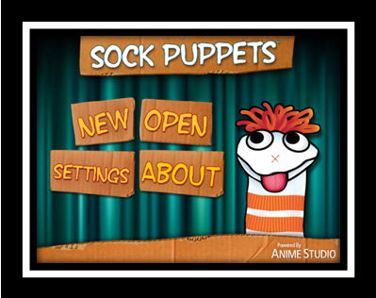
- Open the Sock Puppets App
- This screen allows you to:
  - New: Create a New Show
  - Open: Open a saved Show
  - About: License and help information
  - Settings: Record a sample of your voice to manipulate voice settings
- Tap New
Selecting Character(s)
- Select up to 4 different characters to include in your show by tapping on a character.
- Choose 2 different characters by tapping on their picture.
- An eyeball icon will appear on selected characters.
- 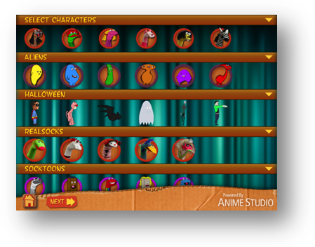To deselect a character, simply tap the character again to make the eyeballs disappear.
- Tap Next.

Selecting Background(s)
- A maximum of 5 backgrounds can be used in a show.
- 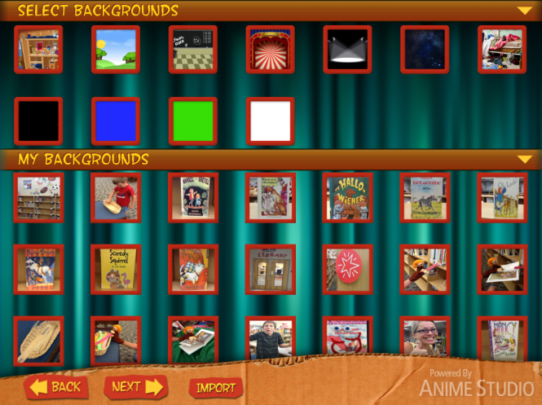You can use preloaded backgrounds from the app OR import pictures from your camera to use as a background.
- Tap Import at the bottom of the screen.
- Tap Camera Roll
- Your photos will appear.
- Select a photo you would like to use as a background by tapping on the photo
- The photo will automatically drop into the area entitled “My Backgrounds”
- Tap one preloaded app background to use in your show.
- Select the background image you imported.
- Both backgrounds should display a set of eyeballs.
- Tap Next
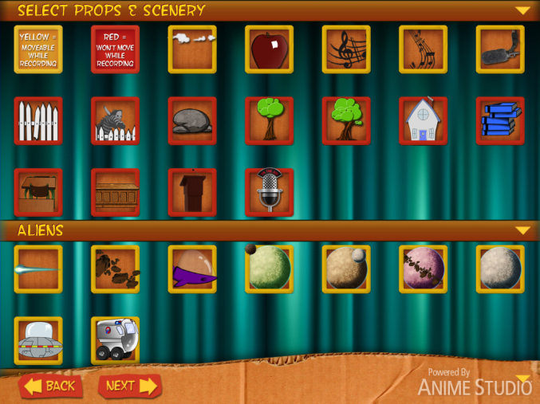Selecting Props & Scenery
- A maximum of 4 props and scenery can be added to a show.
- Props & scenery incased in a yellow box are moveable while recording.
- Props & scenery incased in a red box will not move while recording.
- Select 2 items from this screen. One that is moveable (yellow box) and one that is not (red box) by tapping on the picture.
- Eyeballs will appear on selected items.
Recording your Sock Puppets Show
- Arrange items on the screen.
- Each item can become larger or smaller by pinching and expanding or collapsing.
- Items with a red arrow above can be moved while recording. Items without the red arrow remain stationary.
- Chosen backgrounds are displayed on the top right of the screen.
- 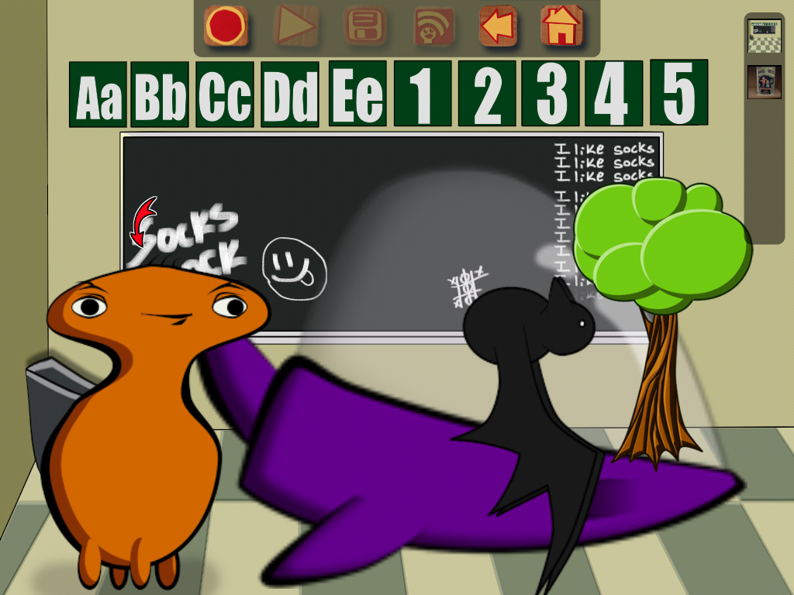Select the background you want to display first by tapping on the background.
- Tap the Red Circle to begin recording your show.
- Speak loud enough for microphone to record your voice.
- The character with the red arrow above it is the one “talking.”
- Switch between characters talking by simply tapping on the character.
- Change backgrounds during recording by simply tapping on new background.
- Press the Square Stop Button to Stop Recording.
Menu Bar
- Square Stop Button: Stops the recording
- Triangle Play Button: Plays back the recorded show
- Disk Button: Saves your project with a Title
- Person/Share Button: Allows you to share your show via –
  - Facebook
  - YouTube
  - Photos: Saves to your Photo Reel
- Go Back: Goes back to previous screen without saving your project.
- Home: Back to home screen without saving current project
Saving Your Sock Puppets Show to Use in iMovie
- Tap the Disk Button on the Menu Bar
- Type in a title for your show
- Tap the Person/Share Button on the Menu Bar
- Tap the Photos Button
- An encoding bar will appear across the screen. This might take a few minutes.
- Once done, it will bring you back to your show screen.
- Tap the Home Button
- Close the App
- Find your Sock Puppets Show on your iPad by opening the Photos App.
- This show is now accessible when you open iMovie

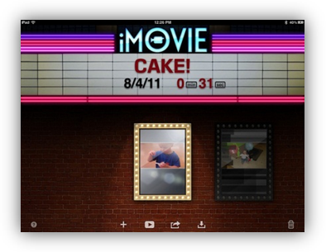Creating an IMovie
- Open the iMovie App
- To create a new movie Tap the +
- Select New Project. The iMovie screen is split into 3 parts:
- Video/Photos/Audio pane on the top left.
- Timeline at the bottom
- Project window at the top right
iMovie App Orientation
Menu Bar
- The Menu Bar at the top of the screen includes:
  - Back Button: Goes back to main iMovie screen that holds all your current iMovie projects.
  - Help: Pressing the question mark button will display help for different features on the current screen.
  - Project Name: Once you give your project a title it will display on the Menu Bar.
  - Arrow: Tap the arrow to undo the last action. Touch and hold the arrow to redo.
  - Project Settings: Here you can change the slide theme, background music, and make added photos and video fade in and out from black.
- The 7 icons on the Tool Bar include (from left to right)
Tool Bar
  - Video Reel: Shows videos from the video iPad reel
  - Photo Reel: You can either choose to include pictures from your Camera Roll or Photo Library on the iPad
  - 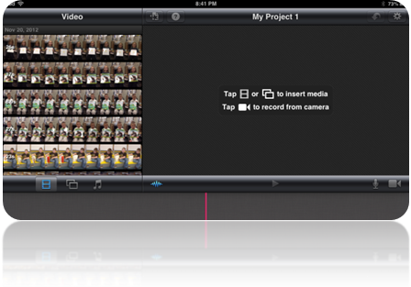Audio Reel: The iMovie app includes several sound effect options. You can also import music from your iTunes account.
  - Audio Waveforms: This is a visual representation of the audio clips in your iMovie. This can help you to visually line up and/or clip audio components in the film.
  - Play Button: Tapping this plays the movie.
  - Microphone: This allows you to record and add audio to your movie.
  - Video: Record video and add to your movie.
Adding Video
- Tap on the Video Reel icon located on the toolbar. This icon looks like a film strip. The videos on your iPad will populate in the top left pane.
- Choose the Sock Puppets video you created to include in your iMovie project.
  - Tapping once highlights the selected video and allows you to:
    - Play Button: Plays the video in the in the project window on the right side of the screen
    - Blue Arrow: Adds the video to your project
    - Trim: The video clip can be trimmed by pressing and sliding the two yellow buttons on the highlighted clip.
  - Double tapping the video in the Video Reel Pane will automatically drop the selected video into the timeline.
- Double tap the selected video to add to your project.
- Your Sock Puppets video will drop into the timeline.
Manipulating Video
- Tap on the video in the timeline.
- It will become highlighted in yellow.
- Double tap the highlighted video strip.
- A Clip Settings Box appears:
  - Title: Add wording to the beginning, middle, or end of a video or picture.
  - Location: Add your current location
  - Volume: Adjust the volume of the video clip
  - Delete: Delete the video clip from the timeline
- Tap on the timeline to close the Clip Settings Box.
- Video clips can also be deleted by simply pressing down and dragging the clip to the Project Window.
Recording a Video in the iMovie App
- Make sure the red needle bar is located in the correct spot in the timeline. This is where the recorded video will be added.
- Move the timeline so the Red Needle is in the place you want to add recorded video.
- Press the Video Icon on the toolbar. The iPad video recorder will appear.
- Press the Red Circle to record a short video. Record your audio message.
- Press the Blinking Red Circle to end recording.
- You have 3 choices:
  - Retake: Rerecord a video
  - Play: Play the current video
  - Use: Accept and insert the current video into your iMovie Project.
- Tap Use
- Your recorded video will appear in the timeline.
Remember any item – audio clip, photo, video, etc. can be simply deleted by dragging to the My Project Window.
Adding Photos
- Tap on the Photo Reel icon located on the toolbar. This icon looks like rectangles. Photos are accessible from your Camera Roll or Photo Library.
- Select Camera Roll.
- Insert photos by tapping once or twice on the photo in the Camera Roll Pane. Photos will begin to drop into the timeline below.
- Add 3 photos to your project.
Manipulating Photos
- Tap on a photo in the timeline.
- It will become highlighted in yellow.
- Double tap the highlighted photo.
- A Photo Settings Box appears:
  - Location: Add your current location
  - Delete: Delete the photo from the timeline
  - Title: Add wording to the beginning, middle, or end of a video or picture.
    - Tap on Title Style
    - Tap on Opening
    - A text box will appear on the photo in the Project Window
    - Tap in the text box in the Project Window
    - The keyboard will appear
    - Type in a few words to describe the photo.
    - Press Done
- Photos can also be deleted by simply pressing down and dragging the clip to the Project Window.
- To adjust the length a photo is seen:
  - Select a photo in your timeline
  - The photo becomes highlighted in yellow
  - Hold, press, and then move the yellow ball to adjust the length a photo is displayed in your project.
- To zoom in on a photo:
  - Tap on a photo in the timeline
  - This will highlight the photo in yellow
  - It will also display the photo in the Project Window at the top right of the screen
  - The Red Needle should be at the beginning of your photo on the timeline.
  - In the Project Window drag to position a photo
  - Pinch to zoom
  - Select Done in the Project Window when finished.
Taking a Photo in the iMovie App
- Make sure the red needle bar is located in the correct spot in the timeline. This is where the photo will be added.
- Move the timeline so the Red Needle is in the place you want the photo to be added.
- Press the Video Icon on the toolbar. The iPad video recorder/camera will appear.
- Switch to camera mode by swiping the bar on the bottom right side of the screen from Video Camera to Camera.
- Press the Camera Circle to take a photo.
- You have 2 choices:
  - Retake: Retake the photo.
  - Use: Accept and insert the photo into your iMovie Project.
- Tap Use
- Your photo will appear in the timeline.
Remember any item – audio clip, photo, video, etc. can be simply deleted by dragging to the My Project Window.
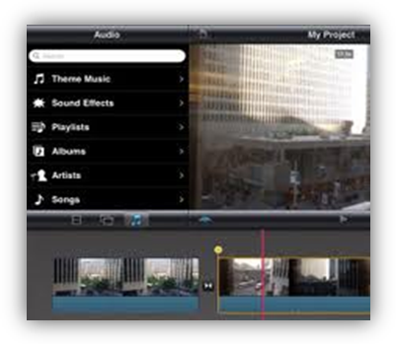Adding Sound
There are several different options for adding audio to your iMovie project. They include:
- Recording audio directly to your iMovie project
- Importing Sound effects and/or songs from your Playlist from iTunes
- Using a sound effect that is already installed in the app (iMovie has over 50 prerecorded apps available for your use).
Recording Audio in the iMovie App
- Make sure the red needle bar is located in the correct spot in the timeline. This is where the recorded audio will be added.
Red needle
- Move the timeline so the Red Needle is at the beginning of one of your photos on the timeline.
- Press the Microphone Icon on the toolbar. A “Ready to Record” box will appear.
- Press Record. It will give you a 3, 2, 1 countdown before it starts recording.
- Record your audio message.
- Press Stop to end recording.
- A “Recording Finished” box will appear. You can either press:
    - Cancel – cancel the entire recording
    - Retake – Deletes the current recording but allows you to record a new message
    - Review – Plays back the current recording
    - Accept- Inserts the current recording into the iMovie timeline
- Tap Accept
- A purple recorded audio clip will drop into your timeline.

Manipulating Recorded Audio Clips
- Once an audio recording has been added to the iMovie timeline, it can be easily moved to another part of the project by simply pressing and holding down on the purple recorded audio clip and dragging it to another area of the project.
  - Press down and hold the purple audio clip that was just recorded.
  - Drag it to another spot on the timeline.
- To delete an audio clip, double tap on the clip.
  - An “Audio Clip Settings” box appears
    - You can turn the clip ON or OFF by swiping the ON/OFF button
    - You can adjust the volume of the clip
    - You can delete the clip by tapping “Delete Clip”
- Practice adjusting the volume on your recorded audio clip by turning the volume all the way up.
Using Playlist Audio and Sound Effects
- 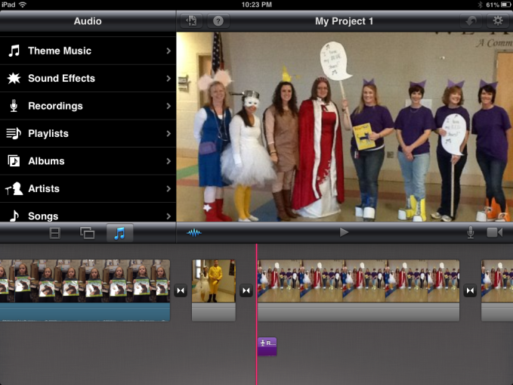Make sure the red needle bar is located in the correct spot in the timeline. This is where the audio will be added.
- Press the music note located on the tool bar.
- You can choose to upload audio from:
    - Theme music: Preloaded music from the iMovie App
    - Sound Effects: Over 50 sound effects that come with the iMovie App
    - Recordings: Sound recordings you have made in the iMovie app
    - Playlists, Albums, Artists, and Songs: All from your iTunes account
- Tap Sound Effects
- Scroll down to find Dinosaur Growl
- Tap the play button on the right of each sound to hear it.
- Tap Dinosaur Growl to add it to your iMovie project
- The sound effect will drop to your timeline.
Manipulating Audio Clips
- Once an audio clip has been added to the iMovie timeline, it can be easily moved to another part of the project by simply pressing and holding down on the Blue Audio Clip and dragging it to another area of the project.
  - Press down and hold on the Blue Audio Clip that was just inserted.
  - Drag it to another spot on the timeline.
- To delete an audio clip, double tap on the clip.
  - An “Audio Clip Settings” box appears
    - You can turn the clip ON or OFF by swiping the ON/OFF button
    - You can adjust the volume of the clip
    - You can delete the clip by tapping “Delete Clip”
- Practice adjusting the volume on your sound effect by turning the volume down low.
Remember any item – audio clip, photo, video, etc. can be simply deleted by dragging to the My Project Window.
Playing your iMovie Project
- Move timeline so the Red Needle is at the beginning of your project.
- Press the Play button on the Tool Bar
- Your iMovie Project will play in the My Project Screen
Naming an iMovie Projects
- Tap the Back to Projects button on the Menu Bar at the top of the screen. This icon looks like a sheet of paper with a star in it.
- Tap in the Title area of the screen. It will say “My Project”
- The keyboard will appear
- Give your iMovie Project a Title by typing on the keyboard
- Tap Done
Final iMovie Options
- From the main iMovie App screen you can:
  - + Create a new project
  - 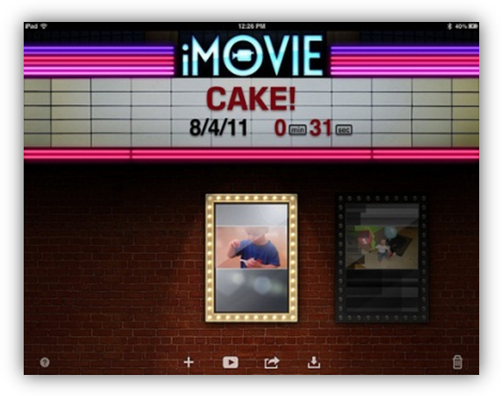Play the highlighted project
  - Share the iMovie project to:
    - Cameral Roll
    - YouTube
    - Facebook
    - Vimeo
    - CNNiReport
    - iTunes
  - Copy projects from iTunes
  - Delete a highlighted Project

Formative Evaluation Assessments
Approach 1: Teacher Questionnaire/Survey:
Session 1 - Introduction to iPad Basics
During the last month of the school term 2012 - 2013, an e-mail with a link to a Google Form with questions related to basic functions of using the iPad will be sent out to teachers/participants for the purpose of gaining information that will guide the Introduction session for using the iPad.
iPad Basics
Session 2 - Apps
At the end of the iPad Basics session, participants will be sent a link via email for the Apps Formative Evaluation.
Apps Formative Evaluation
Session 3 - Creating an iMovie
At the end of the Apps session, participants will be sent the following link via e-mail
for the iMovie Formative Evaluation.
iMovie Formative Evaluation
Session 4 Creating iMovie Integrating Apps
At the end of the iMovie session, participants will be sent the following link via e-mail
for the Creating iMovie Integrating Apps Formative Evaluation.
Creating iMovie Integrating Apps
Session 5 Apple TV and Presentation of iMovie
At the end of the Creating iMovie Integrating Apps session, participants will be sent the following link via e-mail for the Apple TV and iMovie Presentation.
Apple TV and iMovie Presentations
Approach 2: One-to-One Interview and Observation of Users in a Focus Group
The following interview questions are suggested questions to use during one-to-one interview sessions. Some questions may be eliminated depending on the answers as the interview takes place. For instance, if the participant doesn’t know how to turn on the iPad, it could be assumed that the participant has no prior knowledge about flipping through different screens.
Do you have any knowledge and/or experience with using an iPad? If so, please elaborate.
Do you know how to turn the iPad on and off?
Do you know how to flip through different screens on the iPad?
Do you know how to open an app on the iPad?
Do you know how to open up an iTunes account?
Do you know how to locate, install, and /or remove apps?
Are you familiar with the following photo features of the iPad: taking, viewing, and deleting photos?
Is your familiar with the video capabilities of the iPad?
Are there any features that you are aware of for which the iPad device can be used?
Are their any specific apps in which you are specifically interested?
Have you ever heard of or used iMovie?
Have you ever heard of or used Sock Puppets?
Do you know how to upload a movie into a photo reel?
Summative Evaluation Assessments
Approach 1: Participant Survey
iPads in Elementary Education Final Survey
Approach 2: Focus Group
The instructional design team will introduce themselves and thank the focus group for agreeing to participate. The instructional design team will video record the session, informing participants of their rights of being involved, which include the rights to stop their involvement at any time. An official consent form will be given to each person in the focus group and collected prior to recording the session. The instructional design team will use the following questions to acquire information and provoke discussion about the effectiveness of the training. The questions are not intended as a script, but as a guide to gain meaningful data from the participants for the purpose of determining the effectiveness of the training sessions.
- Have you had the opportunity to apply what you have learned from the training sessions, using the iPad for instructional purposes?
- What is your opinion about iPad devices?
- In your experience, do you believe integrating iPad devices into one’s curriculum is an effective means of instruction?
- Can iPads serve as an effective learning tool in the classroom?
- What motivation can be offered to convince other teachers to use an iPad device?
- In your opinion, is face-to-face instructional training an effective delivery for training teachers to use the iPad in the classroom?
- Have you located other apps for instructional purposes?
- Do you feel the iPad is easy to use?
- Have you encountered any technical problems while using the iPad in the classroom?
- Have you encountered any problems while utilizing the Apple TV as presentation tool?
- Have you created an iMovie? If so, how easy or comfortable did you feel in creating the iMovie?
- Have you created a video resource using Sock Puppets? If so, how easy and comfortable did you feel in creating the Sock Puppet presentation?
- Have you referred back to the training resources like the Wiki and the iMovie handouts? If so, did you encounter any problems with using the resources?
- What aspects of the training did you find beneficial? Why did you find these aspects to be beneficial?
- What aspects of the training fell short of your expectations? Why?
- What support do you need as an instructor in order to use the iPad device effectively in the classroom?
- What impact has the training had on student learning?
- Can you think of any additional training you would like to have for finding meaningful uses of the iPad? If so, do you think those uses are more meaningful than those presented during the yearlong training?
- Were there any parts of the training where you felt the training was not useful or a waste of time?
- What recommendations would you make for improving future training sessions?

Learner Characteristics Survey
Getting to Know the Participants

Appendix B
Materials
Link to a Wiki with iPad help, tutorials, and a forum to post project ideas and ask questions:
http://imovieforipad.pbworks.com/w/page/61625430/iMovie

